**MINI PROJECT REPORT**

**ON**

“ QR Code Generator ”

# Submitted By :- Submitted To :-

**Name :-** Moirangthem Satyabrata Ms. Payal Sharma (E13636)

**UID :-** 24MCA20343

**Branch :-** MCA Date of Submission: 01/04/2025

**Semester :**- 2nd

**Subject :-** Front – End Technology

# Subject Code :- 24CAH-655

# Date of Performance :- 25/03/2025

**University Institute of Computing**

**Chandigarh University, Gharuan, Mohali**

# DECLARATION

We hereby declare that this submission is our own work and that, to the best of mine knowledge and belief, it contains no material previously published or written by another person nor material which to a substantial extent has been accepted for the award for any other degree or diploma of the university or other institute of higher learning, except where acknowledgement has been made in the text.

Name :- Moirangthem Satyabrata

UID :- 24MCA20343

Session 2024 – 26

# CERTIFICATE

It is to certify that Moirangthem Satyabrata of class MCA 1st Year under University Roll Number :- 24MCA20343 has completed the project titled “ QR Code Generator ” in which the language used is HTML, CSS, JavaScript for the Masters of Computer Application 2nd Semester under my supervision. The work done in project is a result of the candidate’s own efforts and report maintains is satisfied as per requirement.

Project Guide :-

Ms. Payal Sharma (E13636)

## INDEX

|  |  |
| --- | --- |
| **Sl.No.** | **Content** |
| **1** | **INTRODUCTION** |
| **2** | **ABSTRACT** |
| **3** | **OBJECTIVE** |
| **4** | **LIMITATION** |
| **5** | **TECHNOLOGY USED** |
| **6** | **FEATURE SCOPE** |
| **7** | **CODE** |
| **8** | **OUTPUT** |
| **9** | **CONCLUSION** |
| **10** | **GITHUB** |

**Introduction**

A QR Code Generator is a digital tool that allows users to create Quick Response (QR) codes, which are two-dimensional barcodes that store information such as URLs, text, contact details, or payment details. These QR codes can be scanned using smartphones or other QR code readers, providing instant access to the stored data.

With the increasing demand for contactless interactions and easy information sharing, QR codes have become widely used in business, marketing, education, and personal applications. This generator simplifies the process of creating QR codes, making information accessible with just a quick scan.

**Abstract**

With the growing need for quick and efficient data sharing, QR codes have become a widely used technology for encoding information in a scannable format. This project, QR Code Generator, is developed using HTML, CSS, and JavaScript to provide a simple yet effective way to generate QR codes dynamically in a web-based environment.

The application enables users to enter text, URLs, or other data and instantly generate a QR code. It utilizes JavaScript along with the QRCode.js library to convert user input into a scannable QR code. The generated QR code can be downloaded as an image, making it convenient for both digital and print use.

The interface is designed with CSS for an intuitive user experience, ensuring easy navigation and responsiveness across different devices. The project eliminates the need for backend processing, making it a lightweight and fast solution for businesses, digital payments, authentication, and personal use.

By integrating front-end technologies, this project showcases how JavaScript can be leveraged for real-time QR code generation, allowing seamless information encoding without requiring server-side processing.

**Objective**

The **QR Code Generator** project aims to provide a simple and efficient way for users to generate QR codes dynamically using only **HTML, CSS, and JavaScript**. With the increasing use of QR codes in various fields such as digital payments, authentication, business promotions, and contactless transactions, this tool offers a user-friendly interface to convert text, URLs, or other information into a scannable QR code instantly. By eliminating the need for complex backend processing, the project ensures a lightweight and responsive experience, making it accessible to users on different devices.

This project also focuses on enhancing the **usability and customization** of QR codes. Users can generate QR codes in real time, download them as images for offline use, and integrate them into various applications. With a clean and minimalistic UI built using **CSS**, the tool ensures a smooth experience. Additionally, leveraging **JavaScript and the QRCode.js library**, the project demonstrates the power of front-end web technologies in simplifying tasks that traditionally require external software or APIs

### Technology Used

Introduction to HTML, CSS, and JS :-

**HTML (Hypertext Markup Language) :-** HTML is the foundational markup language used to create the structure of web pages. It consists of a series of elements or tags that define the various components, such as headings, paragraphs, links, images, and forms.

**Use in the Project :-** In the Manipur Tourism project, HTML is used to create the basic structure and layout of the web pages, including sections for information on tourist destinations, festivals, and local attractions. HTML forms are also used for feedback submission or inquiries.

**CSS (Cascading Style Sheets)** :- CSS is a stylesheet language that controls the presentation and layout of web pages written in HTML. It enables developers to apply styles, such as colours, fonts, spacing, and positioning, to enhance the visual appeal and user experience.

**Use in the Project :-** CSS is applied in the Manipur Tourism project to style the HTML elements, providing a visually appealing design that reflects Manipur’s cultural vibrancy. It enhances the layout of tourist information sections, making them more accessible and engaging for visitors, and ensures that the site is visually consistent across all pages.

**JS (JavaScript) :-** JavaScript is a programming language commonly used to add interactivity, dynamic content, and functionality to web pages. It enables users to interact with the webpage in real-time without needing to reload the page.

**Use in the Project :-** JavaScript is utilized in the Manipur Tourism project to add interactivity, such as image sliders for showcasing tourist spots, a search feature to quickly find information on specific destinations, and form validation for user submissions. This enhances the user experience and makes navigating the website smoother and more engaging.

### Feature Scope

The **QR Code Generator** will include the following key features to enhance usability and functionality :-

**1. Real-Time QR Code Generation**

* Users can enter text, URLs, or any data, and a QR code will be generated instantly without requiring a page refresh.

**2. Customizable QR Code**

* Users can modify the size of the QR code as per their requirements.
* Options to change the foreground and background colors for better contrast and branding.

**3. Download & Save Functionality**

* Allows users to download the generated QR code as a PNG or SVG image file for offline use.

**4. Future Enhancements**

* A well-designed and minimalistic UI using HTML and CSS to ensure a smooth experience on desktops, tablets, and mobile devices.

**5. Error Handling & Validation**

* The tool will include input validation to ensure that only valid data is processed.
* Error messages will guide users in case of incorrect inputs.

**6. Lightweight & Fast Processing**

* Built using pure JavaScript (QRCode.js) without the need for additional backend processing, making it highly efficient and lightweight.

**7. Multiple Output Formats (Future Scope)**

* Support for exporting QR codes in different formats like PDF or vector graphics for high-resolution printing.

**Limitation**

1. **Limited Data Capacity**

* QR codes have a maximum data capacity, and large amounts of text, URLs, or encoded files may result in reduced readability or larger QR codes.

1. **Dependency on Scanning Devices**

* The generated QR codes can only be used if users have a compatible QR code scanner, such as a smartphone camera or a third-party app.

1. **Limited Customization Options**

* While color and size can be customized, advanced customizations like embedding logos, gradient colors, or animations may require additional tools.

1. **Internet Dependency (For Some Features)**

* If the QR code is linked to an online URL, users must have an active internet connection to access the encoded content.

1. **Potential for Scanning Issues**

* Poor contrast between foreground and background colors or excessively small QR codes may lead to scanning difficulties.

1. **No Built-in Security Features**

* The tool does not provide encryption or password protection for QR codes, making it unsuitable for highly confidential data.

1. **Static QR Codes**

* Once a QR code is generated, it cannot be edited or updated. Users must generate a new QR code if they need to change the content.

1. **No Analytics or Tracking**

* Unlike dynamic QR codes, this generator does not provide insights such as the number of scans, location of users, or time of scanning.

## Code

### HTML :-

<!DOCTYPE html>

<html lang="en">

<head>

    <meta charset="UTF-8">

    <meta name="viewport" content="width=device-width, initial-scale=1.0">

    <title>Multipurpose QR Code Generator</title>

    <link rel="stylesheet" href="QR Code Generator.css">

    <script src="https://cdnjs.cloudflare.com/ajax/libs/qrcodejs/1.0.0/qrcode.min.js"></script>

    <script src="https://cdn.tailwindcss.com"></script>

    <link href="https://fonts.googleapis.com/css2?family=Dancing+Script:wght@600&display=swap" rel="stylesheet">

</head>

<body class="h-screen flex flex-col items-center justify-center text-center text-gray-900 relative">

    <!-- Home Screen -->

    <div id="homeScreen" class="flex flex-col items-center justify-center">

        <h1 class="text-5xl font-bold mb-4">Multipurpose QR Code Generator</h1>

        <p class="text-xl">Create secure QR codes for text, numbers, or images.</p>

        <button onclick="startGenerator()" class="mt-6 bg-blue-500 text-white px-6 py-3 rounded-lg shadow-lg hover:bg-blue-600 transition duration-300">

            Start Generator

        </button>

    </div>

    <!-- QR Code Generator Screen -->

    <div id="qrScreen" class="hidden flex items-center justify-center">

        <div class="bg-white p-8 rounded-xl shadow-lg w-full max-w-md">

            <h2 class="text-3xl font-bold text-center mb-4">Generate Your QR Code</h2>

            <input type="text" id="qrInput" class="w-full p-3 border rounded-lg mb-3 text-lg" placeholder="Enter text, number, or image URL">

            <button onclick="generateQR()" class="w-full bg-blue-500 text-white py-3 rounded-lg hover:bg-blue-600 transition duration-300">

                Generate QR Code

            </button>

            <div class="flex justify-center mt-4">

                <div id="qrCode" class="p-4 bg-gray-200 rounded-lg"></div>

            </div>

            <p id="fakeAddress" class="text-lg text-gray-500 text-center mt-2 hidden">

                Generated for: <span class="font-semibold">https://example.com/xyz123</span>

            </p>

            <button id="downloadBtn" class="hidden w-full bg-green-500 text-white py-3 mt-3 rounded-lg hover:bg-green-600 transition duration-300" onclick="downloadQR()">

                Download QR

            </button>

            <button onclick="goHome()" class="w-full bg-red-500 text-white py-3 mt-3 rounded-lg hover:bg-red-600 transition duration-300">

                Back to Home

            </button>

        </div>

    </div>

    <script src="QR Code Generator.js"></script>

</body>

</html>

### CSS :-

body {

    background: rgb(132, 132, 239);

    font-family: 'Dancing Script', cursive;

    overflow: hidden;

    position: relative;

}

/* Falling Petals Animation */

@keyframes fall {

    0% { transform: translateY(-10px) rotate(0deg); opacity: 1; }

    100% { transform: translateY(100vh) rotate(360deg); opacity: 0; }

}

.petal {

    position: absolute;

    width: 20px;

    height: 20px;

    background: pink;

    border-radius: 50%;

    opacity: 0.7;

    animation: fall 8s infinite linear;

}

/* Twinkling Stars */

@keyframes twinkle {

    0%, 100% { opacity: 0.2; transform: scale(1); }

    50% { opacity: 1; transform: scale(1.5); }

}

.star {

    position: absolute;

    width: 6px;

    height: 6px;

    background: gold;

    border-radius: 50%;

    box-shadow: 0 0 10px gold;

    animation: twinkle 3s infinite alternate;

}

/* Background with Lavender and Saffron Blend */

body {

    background: linear-gradient(135deg, #E6E6FA, #FF9933);

    font-family: 'Dancing Script', cursive;

    height: 100vh;

    margin: 0;

    overflow: hidden;

}

/* Centered content */

.centered-box {

    position: absolute;

    top: 50%;

    left: 50%;

    transform: translate(-50%, -50%);

    text-align: center;

    padding: 30px;

    border-radius: 20px;

    background: rgba(255, 255, 255, 0.2); /* Glassmorphism effect */

    box-shadow: 0px 4px 15px rgba(0, 0, 0, 0.2);

    backdrop-filter: blur(10px);

}

/* Custom font for headings */

h1, h2 {

    font-family: 'Pacifico', cursive;

}

/* Button styling */

button {

    font-family: 'Dancing Script', cursive;

    font-size: 20px;

}

### JS :-

function startGenerator() {

    document.getElementById("homeScreen").classList.add("hidden");

    document.getElementById("qrScreen").classList.remove("hidden");

}

function generateQR() {

    let qrInput = document.getElementById("qrInput").value;

    let qrCodeDiv = document.getElementById("qrCode");

    let downloadBtn = document.getElementById("downloadBtn");

    if (qrInput.trim() === "") {

    alert("Please enter a valid input!");

    return;

}

qrCodeDiv.innerHTML = ""; // Clear existing QR Code

new QRCode(qrCodeDiv, {

    text: qrInput,

    width: 200,

    height: 200

});

setTimeout(() => {

    downloadBtn.classList.remove("hidden");

 }, 500);

}

function downloadQR() {

let qrCanvas = document.querySelector("#qrCode canvas");

if (!qrCanvas) {

alert("Generate a QR code first!");

    return;

}

let qrImage = qrCanvas.toDataURL("image/png");

let link = document.createElement("a");

link.href = qrImage;

link.download = "QRCode.png";

link.click();

}

function goHome() {

    document.getElementById("qrScreen").classList.add("hidden");

    document.getElementById("homeScreen").classList.remove("hidden");

}

// Function to create falling stars

function createStars() {

    for (let i = 0; i < 30; i++) { // Adjust number of stars

        let star = document.createElement("div");

        star.className = "star";

        star.style.left = Math.random() * 100 + "vw"; // Random left position

        star.style.top = -Math.random() * 100 + "px"; // Start above viewport

        star.style.animationDuration = (Math.random() * 5 + 3) + "s"; // Varying speeds

        document.body.appendChild(star);

        // Remove stars after animation ends

        setTimeout(() => { star.remove(); }, 8000);

    }

}

// Generate stars every 1 second

setInterval(createStars, 1000);

## Output of Project

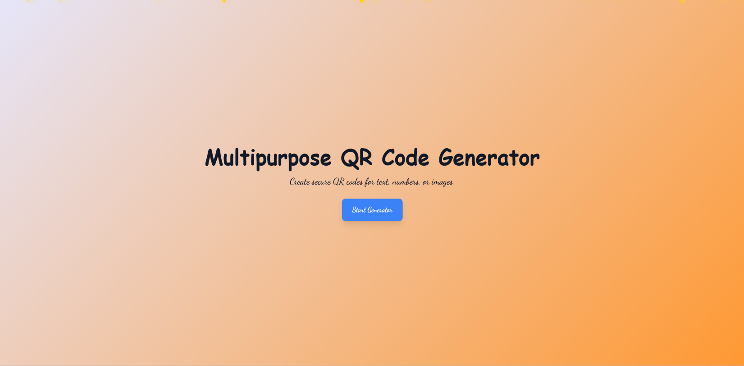

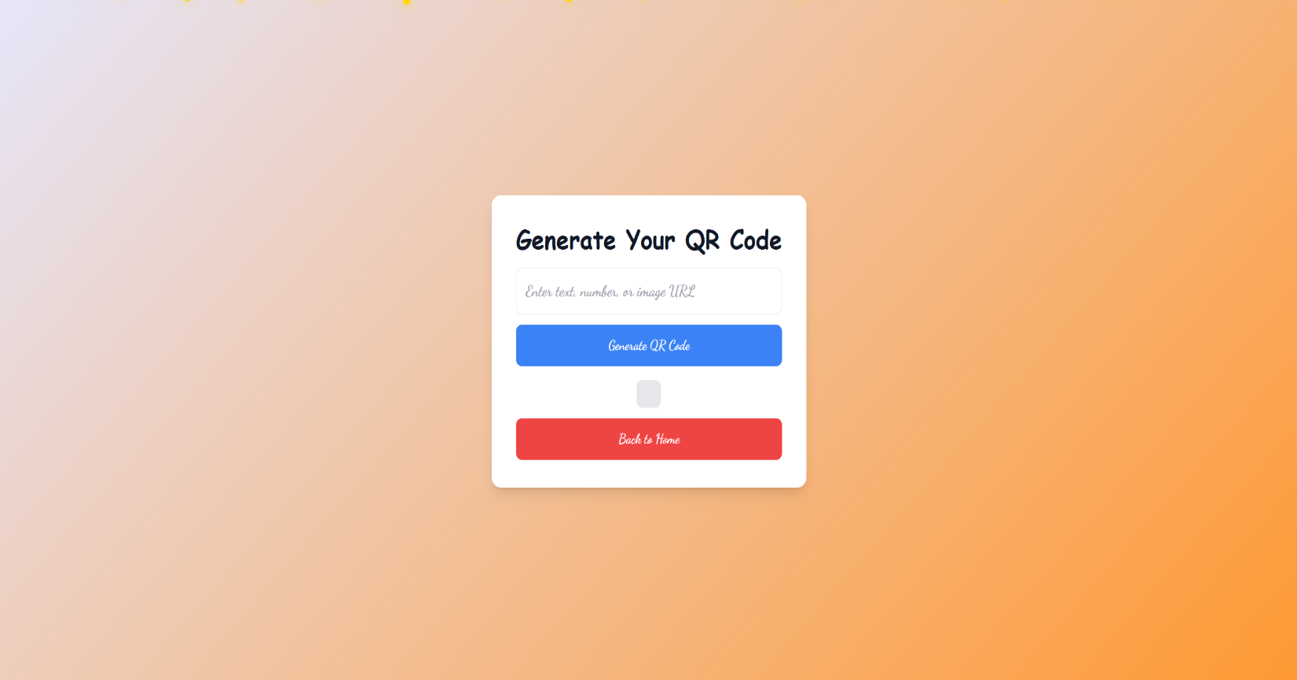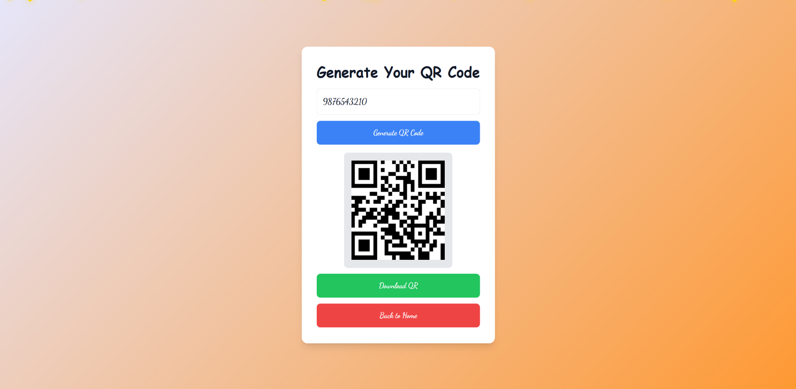

### Conclusion

The QR Code Generator is a simple yet powerful tool that enables users to create scannable QR codes for various applications, such as website links, contact information, and text data. With its ease of use and instant generation capabilities, it enhances accessibility and digital connectivity in both personal and professional environments.

Despite certain limitations, such as static QR codes and limited customization, this tool remains highly efficient for quick sharing of information. As QR code technology continues to evolve, future enhancements may introduce dynamic editing, better security features, and improved analytics. Overall, this QR Code Generator serves as a valuable and convenient solution for modern digital interactions.

### GitHub

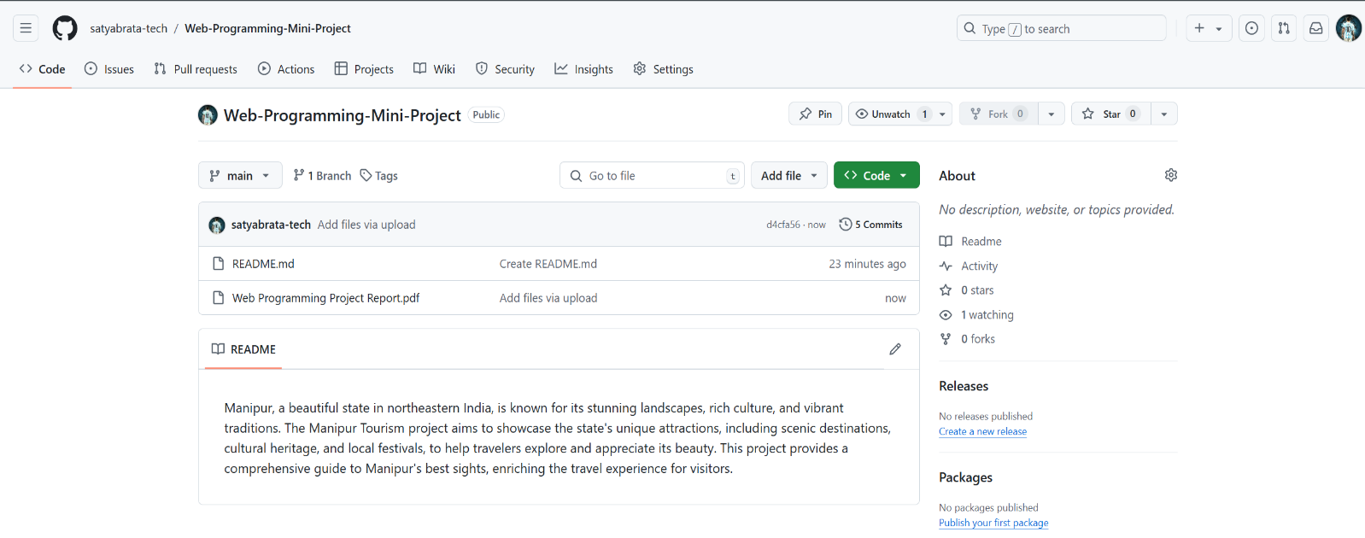

**GitHub Link :-** [**https://github.com/satyabrata-tech/Web-Programming-Mini-Project**](https://github.com/satyabrata-tech/Web-Programming-Mini-Project)